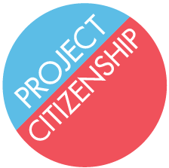

Project Citizenship Workshop Manual

Welcome to the Project Citizenship Workshop Manual. Inside you will find all of the documents necessary for a group processing clinic. Follow the tabs and Table of Contents to divide up the clinic by station. In addition, some documents, such as the N-400 Application for Naturalization and other USCIS forms, can be found online. Copy and Mailing forms are placeholders and need to be created separately. Manila folders are best used for Applicant Folders.

