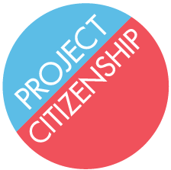
Information on Passport Photo Requirements

General Requirements

- Passport photos must be 2 inches by 2 inches

- The applicant’s head should be centered in the frame

- The applicant’s full head must be showing, from the top of the hair to the bottom of the chin

- The applicant should be facing toward the camera and have a neutral expression

- Photos must have been taken in the last 30 days to reflect the applicant’s current appearance

- The applicant’s A-number must be written in pencil on the back of each photo

A general example is below:

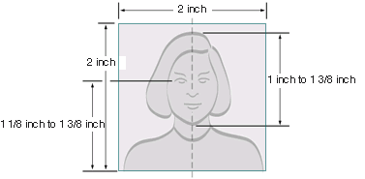

Eyeglasses worn on a daily basis should be worn in the passport photo. There should be no glare from the lenses. Sunglasses are only allowed for medical reasons.

Head coverings may only be worn for religious reasons. Head coverings may not obscure the hair line or cast shadows on the face.

New photos are only required if there has been a significant change in the applicant’s appearance. Growing or shaving a beard or dyeing hair is not considered a significant change.

