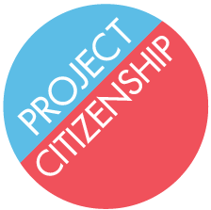
What are my mailing options?
Is your application COMPLETE?
YES
- We can mail your application for you.
OR
- You can mail your application to:
USCIS
PO Box 660060
Dallas, TX 75266

NO
Before mailing your application, you need to complete all the items listed on the missing items sheet. When your application is completed:
- You can bring it to our office and we will mail it for you.
  - Our address: 4 Faneuil South Market Building
3rd Floor, Suite 4025
Boston, MA 02109
- You can mail your application to:
  - USCIS
PO Box 660060
Dallas, TX 75266
¿Que son mis opciones para enviar mi solicitud?
¿Su solicitud está completa?
Sí
- Nosotros podemos enviar su solicitud.
O
- Usted puede enviar su solicitud a:
USCIS
PO Box 660060
Dallas, TX 75266
NO
Su solicitud falta unos documentos. Cuando está completa:
- Puede traerla a nuestra oficina y nosotros la enviamos.
  - 4 Faneuil South Market Building
3rd Floor, Suite 4025
Boston, MA
- Usted puede mandar su solicitud a:
  - USCIS
PO Box 660060
Dallas, TX 75266

