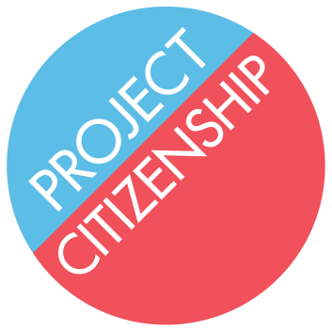
N-400 Application Assistance Checklist
Before Starting:
- You have put your name on the Case Notes sheet in the applicant folder.

- Applicant has signed the Waiver and Information Release Form.

- If using a computer, you have downloaded the N-400 and can see the barcode on the bottom.

- If filling out the application by hand, you are using a black pen.

- Date applicant became an LPR is on or before the date on the preparer memo.

N-400:
- Only one box is checked in Part 1.

- If applying with only 3 years on the basis of marriage, applicant has (or is able to get) a copy of marriage certificate and naturalization paperwork for current spouse (Naturalization Certificate or Birth Certificate if born a U.S. Citizen).

- Part 2 Question 3 includes nicknames, even if the applicant has never used them on paper.

- Residences in Part 4 are listed in reverse chronological order, with the applicant’s current residence first.

- If either of the applicant’s parents is a U.S. citizen, you have flagged down an attorney to check for acquisition or derivation of citizenship.

- Employers/schools in Part 7 are listed in reverse chronological order, with the applicant’s current employer/school first.

- Trips in Part 8 are listed in reverse chronological order, with the most recent trip first. Total days outside the U.S. does not include the day the applicant left or came back to the U.S.

- If any trips lasted longer than six months (180 days), a note has been made on the Case Notes.

- If the applicant or the applicant’s spouse is divorced, applicant has (or is able to get) copies of all marriage and divorce certificates.

- If the applicant is applying based on marriage to a U.S. citizen and says they are separated or the spouse’s address differs from the applicant’s, a note has been made on the Case Notes.

- All children are listed in Part 10, including step-children of current and ex-spouses.

- If applicant answered “Yes” to any question in Part 11, Numbers 1-45, a note has been made on the Case Notes.

- If applicant answered “No” to any question in Part 11, Numbers 47-53, a note has been made on the Case Notes.

- If an interpreter is used and the applicant is eligible for a language exemption listed in Part 2, Number 11 or 12, applicant signed Part 14 and interpreter signed Part 15.

- Applicant’s A-number is on every page of the application, including all addenda.

- If applicant qualifies for a fee waiver, a blue sticker has been placed on the applicant’s folder.

If you have any questions, please find your station captain or anyone wearing a red lanyard.

