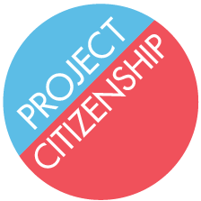

Citizenship for Your Children

If you have children under the age of 18, they may become
U.S. Citizens when you become a U.S. Citizen.

To become a citizen, your children must:
- Be under 18 years old
- Be legal permanent residents (green card holders)
- Currently live with you

If all of those things are true, Project Citizenship can help you apply for a Certificate of Citizenship for your children once you become a citizen.

You will need:
- Your child’s green card
- Your child’s birth certificate
- Proof of your U.S. Citizenship
- Your birth certificate
- Proof of parent’s custody
- $600 (unless eligible for a fee waiver)

Once you have ALL required documents, contact Project Citizenship
at (617) 694-5949 to set up an appointment.

