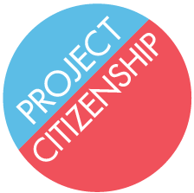
N-400 Preparer Memo

Thank you for volunteering to help legal permanent residents become U.S. citizens today! You will truly make a difference! Below is some information that should aid you as you complete the N-400 Application for Naturalization.

Today’s date is April 6, 2015.
Applicants must have been legal permanent residents since July 5, 2010 (or July 5, 2012 if married to a U.S. citizen) to be able to submit an N-400 today.
The preparer section should be completed as follows:
Preparer Name: _____________________________________
Organization Name: Project Citizenship
Organization Street Address: 4 Faneuil Hall South Market Building
3rd Floor, Suite 4025
City, State, Zip Code: Boston, MA 02109
County: Suffolk
Organization Phone Number: 617-694-5949
Organization Fax Number:
Organization Email Address: _______________________________________
If you have any questions, please ask!

