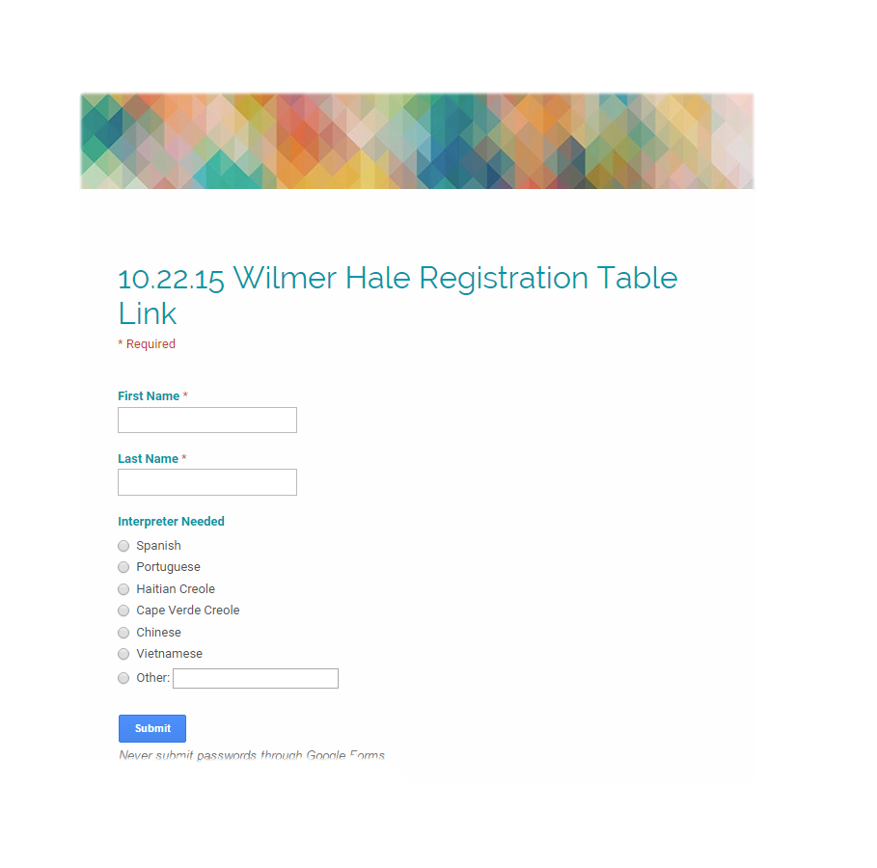

Google Doc registration forms allow applicants to check-in a registration table and have their information to show up in a document based on check-in time. They can then be seated in Application Assistance based on when they arrived.

Registration collects their names and if an interpreter needs to be provided (do not include if they brought someone with them). They are then given their folder and moved to a waiting area or seated at Application Assistance.

