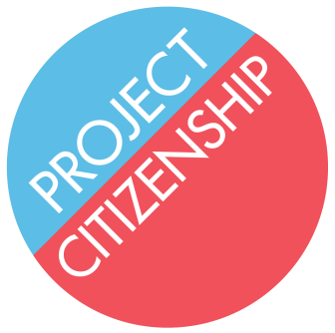

Waiver and Information Release Form

The services you will receive today are not legal representation.

As part of these services, the Project Citizenship will:
- Help you fill out your N-400 Application for Naturalization
- Help you assemble your supporting documents for the Application
- Help you mail the Application

Project Citizenship will not:
- Represent you
- Attend your naturalization interview with you

Putting inaccurate information on your Application could result in denial of your Application or deportation.

In order to avoid these consequences, you must:
- Give accurate information about your personal history, such as: family, travel, income, taxes, voting history, and criminal issues
- Inform Project Citizenship of any criminal issues including arrests, criminal charges, and court appearances, regardless of final outcome
- Provide Project Citizenship with any court or criminal records when they ask for them

Project Citizenship can only fill out your Application correctly if you provide accurate information.

Project Citizenship will not share any of your personal information without your permission.

Project Citizenship will make and keep copies of your Application and other documents. These documents will be stored securely.

Information about your application will be stored on a spreadsheet on a secure server and maintained by Project Citizenship.

You have a right to refuse to sign this Waiver and Information Release Form. Refusal to sign this form will limit Project Citizenship’s ability to help you with your naturalization.

I, ___________________________ certify that I have read and understood the above information.

______________________________ ____________________
Client Signature Date

