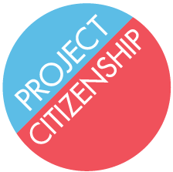
Information on I-912: Request for Fee Waiver

Form I-912 Request for Fee Waiver can waive the $680 application fee for an applicant who:

- Receives a federal or state means-tested benefit such as SNAP (Food Stamps) or Medicaid (MassHealth insurance); OR

- Has a household income at or below 150% of the Federal Poverty Guidelines; OR

- Demonstrates financial hardship, such as recent unemployment or high medical expenses.

Further examples of means-tested benefits and a table of the Federal Poverty Guidelines are included in this binder.

Applicants wishing to request the fee waiver based on their receipt of a means-tested benefit must attach the following proof of the current benefit:

- A letter, notice, or other official document from the agency granting the benefit. The document must include:
  - the recipient’s name AND
  - the name of the granting agency.

A copy of the applicant’s Medicare or other card is not sufficient. If the applicant is currently receiving more than one such benefit, please list and provide evidence for all of them.

This citizenship workshop is only equipped to assist applicants who qualify for the fee waiver by receiving a means-tested benefit. If an applicant qualifies for another reason, please assist the applicant at another time. Project Citizenship will also accept referrals for the Request for Fee Waiver if necessary.

*The above information is for informational purposes only. Project Citizenship cannot make decisions regarding an applicant’s eligibility for the fee waiver. For more information, please visit www.uscis.gov/i-912.

