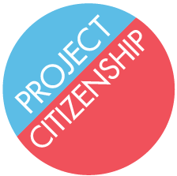
List of Required Documents for Workshop Participants

Complete this form and bring it to the workshop with all of the required items listed below.

- Permanent Resident Card (Green Card)
- Passport to verify travel to foreign countries
- Social Security Card (optional)
- Two passport photos with the applicant’s alien number (A-number) written on the back in pencil
- Money order in the amount of $680 to USCIS for application fee
  - Money order in the amount of $595 to USCIS if applicant is 75 or older
  - Documents for fee waiver:
    - Letter showing receipt of a means-tested benefit (SNAP/food stamps, MassHealth, etc.)
    - Most recent tax return
- List of children’s names, dates of birth, and addresses
- Marriage and divorce certificates for current and prior marriages
- Massachusetts ID or driver’s license (optional)

- Dates of all trips abroad in the past five (5) years:
Date you left the U.S. | Date you returned to the U.S. | Countries to which you traveled

- List of addresses for the past five (5) years:
Street Name and Number | City | Province or State | Country | From  Month Year |  | To  Month Year

- List of employers and/or schools for the past five (5) years:
Full name and address of employer | Occupation | From  Month Year |  | To  Month Year

