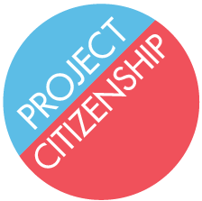
4 Faneuil South Market Building
3rd Floor, Suite 4025
Boston, MA 02109
Phone: 617-694-5949
Fax: 617-859-9993
info@projectcitizenship.org

[ADDRESS]
[ADDRESS]
[ADDRESS]

[DATE]

RE: Letter Confirming That [APPLICANT] (DOB: ) is Competent to Take the Oath of Allegiance to the United States

Dear [Medical Professional]:
Dr. [Name] previously completed the form N-648: Medical Certification for Disability Exceptions on behalf of Mr./Mrs [Name], based on his/her diagnosis of [condition]. The waiver was accepted by USCIS, and Mr./Mrs. [Name] was not required to take the English or civics test during his/her naturalization interview.

Because of [Applicant’s] diagnosis/mental health history, USCIS requires a letter from [Medical Professional] explaining that he/she is competent to take the oath of allegiance to the United States. The letter should state that [Applicant] has never been found to be incompetent/was once found to be incompetent, but has since regained competency. The letter must be signed by [Medical Professional] and must include his/her state license number. Once written, please send the original signed copy to the address above, as soon as possible.
Thank you for your attention to this very important matter. Please do not hesitate to contact me with any questions or if you require additional information.

Sincerely,

