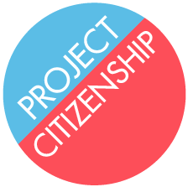
Criminal History Analysis Information

Please complete the following information about your client and then scan or fax this form along with your client’s CORI and/or court dockets to Katie Lambing at klambing@projectcitizenship.org or fax (617) 859-9993. If possible, please try to scan these documents to decrease printing resources. Please also include a copy of the client’s green card and any other relevant documentation.

Referral Agency: ________________________________

A Number: ________________________

Date client originally entered the U.S.: ____ /_____ /_______

Date client became an LPR: ____ /_____ /_______

How client got LPR status (code on green card): ______________

How client originally entered the U.S.:

Entered without inspection (EWI) ______ Parole ______

Non-immigrant (including tourist visas) ______ LPR ______

Has client ever had any other status and/or visa? Yes No
If yes, when and what was the status?

Has the applicant left the U.S. since his/her conviction(s)? Yes No
If yes, when and how long?

I believe the applicant is/is not eligible to move forward with the N-400.
Please explain:

