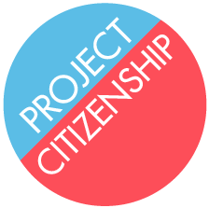
Traffic Incidents

What does Project Citizenship need to do if a client has been issued a ticket for speeding or another moving violation?

- Answer “YES” to Part 12, Question 23 of the N-400.

- Parking tickets do not count.

- Detail the incident in the chart in Part 12, Question 29 of the N-400.

- If the incident involved ANY of the following, the client must obtain the disposition records for Project Citizenship to review and submit with the application:

      - An arrest;

      - Alcohol or drugs;

      - Serious personal injury to another person;

      - A fine of greater than $500;

      - A penalty OTHER than a fine of less than $500 or points on the client’s driver’s license.

- If the incident did NOT involve any of the above, recommend that the client obtain a copy of his or her driving record to bring to the interview.

- The client may request a copy of his or her driving record by contacting the Massachusetts Registry of Motor Vehicles (RMV) or equivalent agency in the state where the traffic incident occurred.

- In Massachusetts, the client can request a true and attested public driving record online for $20 at https://www.mass.gov/how-to/request-a-driving-record. The client may also request a record by phone by calling 857-368-8000 or 800-858-3926, or in person by visiting an RMV Service Center.

