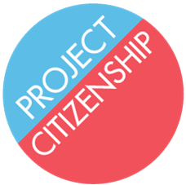
What is the status of my citizenship case?

Once you have received a receipt or fee waiver approval in the mail, you can begin to check the status of your citizenship case online or over the phone. This is usually the second piece of mail you will receive from USCIS (the first mail is an account access notice which does not give information on case status and does not require any action). You will receive the receipt or fee waiver approval generally after 4 to 6 weeks after submitting your application. Make sure to save this notice to continue to check your case status. Please keep in mind that it is normal to wait several months between appointments.

Instructions for checking your case status online:
- Look at your receipt or fee waiver approval notice (see below for example) and find the Receipt Number or Application Number from the top left corner. It usually begins with “NBC” or “IOE”.

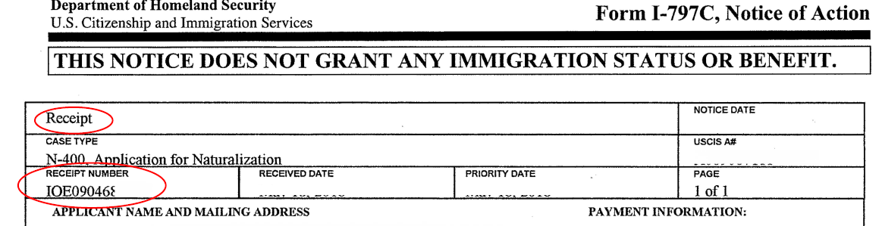

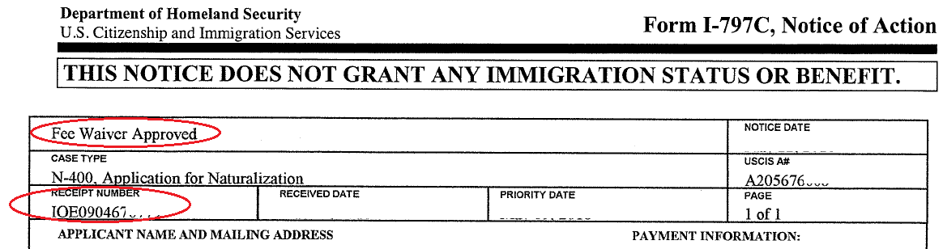

- Go to www.uscis.gov and click “Check your Case Status”. See below for example.
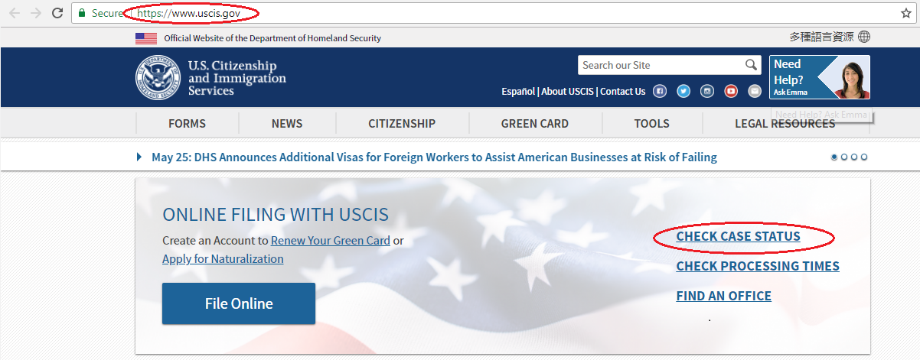

- That will take you to a new page where you can enter your application number or receipt number into the box.
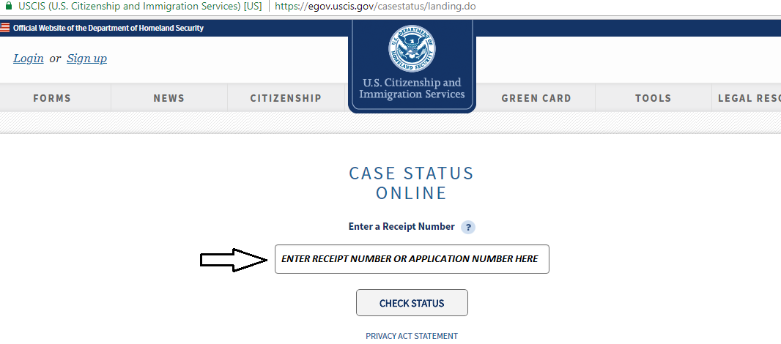

- Once you click “CHECK STATUS”, you will be brought to the page that will tell you the status of your citizenship case.
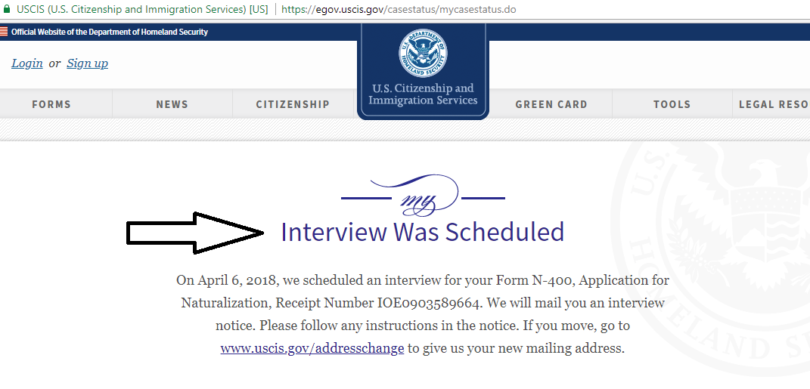

Note: This does NOT provide you with the specific date and time of your appointment(s). It only tells you if an appointment has been scheduled and a notice has been sent in the mail. All appointment dates and times will be sent via post. Please make sure to check your mail regularly. The online status is not always updated on a regular basis and it may not accurately represent the status of the case.

Instructions for checking your case status over the phone:
- Call 1-800-375-5283
- Press 1 to continue in English; Press 2 for Spanish
- Press 1 for immigration services
- Press 1 to check the status of an application
- Press 1 if you know your receipt number
- Enter your 13-character case number (usually begins with NBC* or IOE)
- Press 1 to confirm the number you entered
- Listen to the current status of your case.

