How to Request Your DD-214
- If you do not have an eBenefits account, you need to request your DD-214 using Form SF-180
- Go to https://www.archives.gov/files/research/order/standard-form-180.pdf to find the form
- Fill out Section I with your personal information
- In Section II, check the box next to “DD Form 214 or equivalent”
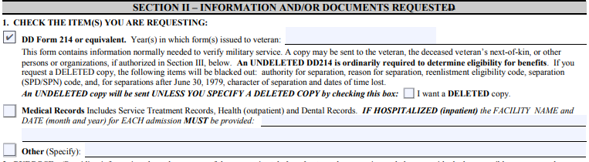
  - DO NOT check the box next to “I want a DELETED copy”- if you check this box, you will have to redo the request
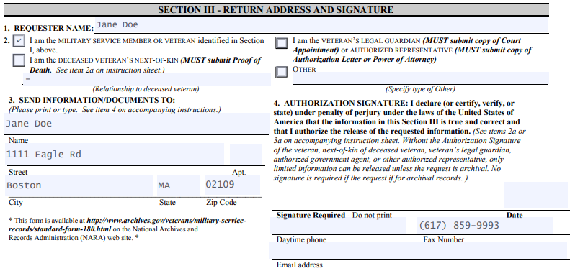
- Under Section III, Question 4, you may write Project Citizenship’s fax number (617) 859-9993. The government will send Project Citizenship a fax in addition to sending you a copy of the form.

- When you are done filling out the form, the quickest way is to fax the form to (314) 801-9195
- Or, mail to: National Personnel Records Center
Military Personnel Records
1 Archive Dr.
St. Louis, MO 63138

