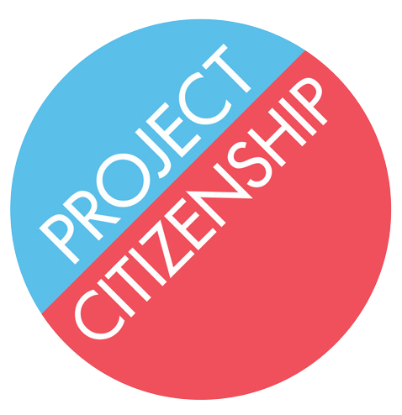
Project Citizenship
4 Faneuil Hall South Market Building 3rd Floor
Boston, MA 02109

ACKNOWLEDGEMENT OF LEGAL REPRESENTATION AND RELEASE OF RECORDS

I, _________________________________________, acknowledge that Erin Fricker, Esq.
(Applicant’s Name)
of Project Citizenship represents me in my pursuit of citizenship in the United States.

I, __________________________________________, further authorize Erin Fricker, Esq.
(Applicant’s Name)
of Project Citizenship to request any and all documents relating to my criminal history, or lack thereof, in this jurisdiction or any other jurisdiction around the world.

I understand that the specific type of documents to be disclosed may include police reports, docket sheets, criminal complaints, police clearance letters, or other documents related to my criminal history.

This consent is effective until such date as I can cancel this consent. I understand that the information obtained as a result of this consent may be used after the cancellation date.

Signed:_______________________________________________________________________ (Applicant’s Name)____

Signed:______________________________________________________________________
(Parent, legal guardian, Surrogate, or Power of Attorney of the applicant, if applicant is unable to sign for themselves)

Address to where records should be sent:

Project Citizenship
4 Faneuil Hall South Market Building
3rd Floor
Boston, MA 02109

Date:______________________________

(617) 694-5949 | www.projectcitizenship.org | Fax: (617) 859-9993

